Book

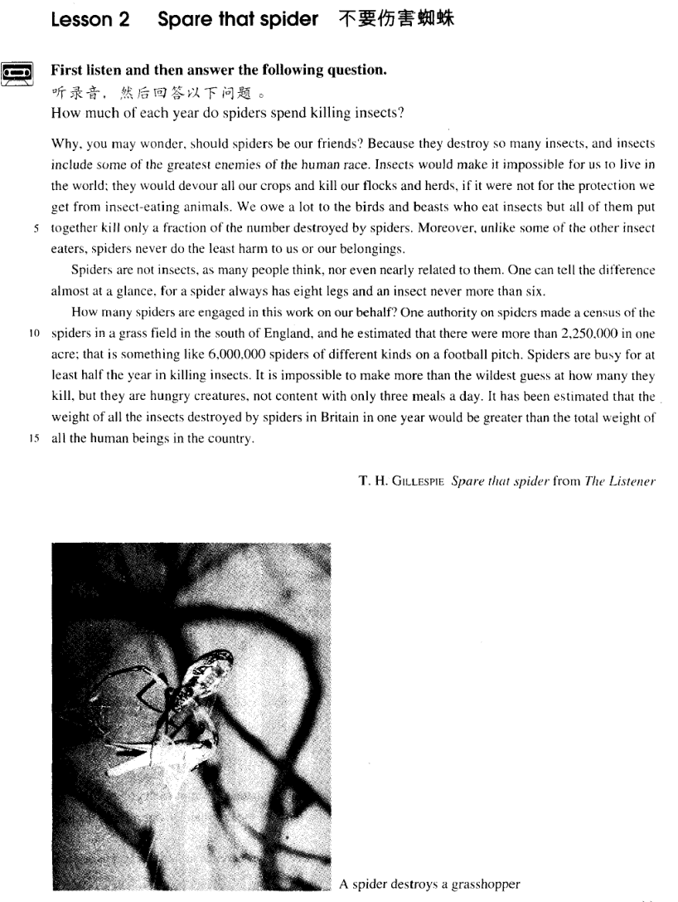

课文

Why, you may wonder, should spiders be our friends?

你可能会觉得奇怪， 蜘蛛怎么会是我们的朋友呢？

Because they destroy so many insects, and insects include some of the greatest enemies of the human race.

因为它们能消灭那么多的昆虫，其中包括一些人类的大敌。

Insects would make it impossible for us to live in the world;

昆虫就会使我们无法在地球上生活下去，

they would devour all our crops and kill our flocks and herds,

昆虫会吞食我们的全部庄稼，杀死我们的成群的牛羊。

if it were not for the protection we get from insect-eating animals.

要不是人类受一些食虫动物的保护，

We owe a lot to the birds and beasts who eat insects but all of them put together kill only a fraction of the number destroyed by spiders.

我们要十分感谢那些吃昆虫的鸟和兽，然而把它们所杀死的昆虫全部加在一起也只相当于蜘蛛所消灭的一小部分。

Moreover, unlike some of the other insect eaters, spiders never do the least harm to us or our belongings. Spiders are not insects, as many people think, nor even nearly related to them.

此外，蜘蛛不同于其他食虫动物，它们丝毫不危害我们和我们的财物。许多人认为蜘蛛是昆虫，但它们不是昆虫，甚至与昆虫毫无关系。

One can tell the difference almost at a glance, for a spider always has eight legs and an insect never more than six.

人们几乎一眼就能看出二者的差异，因为蜘蛛都是8条腿，而昆虫的腿从不超过6条。

How many spiders are engaged in this work on our behalf?

有多少蜘蛛在为我们效力呢？

One authority on spiders made a census of the spiders in a grass field in the south of England,

一位研究蜘蛛的权威对英国南部一块草坪上的蜘蛛作了一次调查。

and he estimated that there were more than 2,250,000 in one acre;

他估计每英亩草坪里有225万多只蜘蛛。

that is something like 6 million spiders of different kinds on a football pitch.

这就是说，在一个足球场上约有600万只不同种类的蜘蛛。

Spiders are busy for at least half the year in killing insects.

蜘蛛至少有半年在忙于吃昆虫。

It is impossible to make more than the wildest guess at how many they kill, but they are hungry creatures, not content with only three meals a day.

它们一年中消灭了多少昆虫，我们简直无法猜测，它们是吃不饱的动物，不满意一日三餐。

It has been estimated that the weight of all the insects destroyed by spiders in Britain in one year would be greater than the total weight of all the human beings in the country.

据估计，在英国蜘蛛一年里所消灭昆虫的重量超过这个国家人口的总重量。

词汇讲解

Lesson 2 Spare that spider beast [bi:st]

n. 野兽

birds and beasts fur and feather fin, fur and feather metonymy 借代

A bald slipped out of the house.

He has been messing around with several skirts of his class. The crown should not yield to the cross.

巾帼不让须眉

过尽千帆皆不是斜晖脉脉水悠悠census ['sensəs]

n. 对数量的统计，普查

the fifth national (population) census road traffic census

investigation

The case is *under* investigation.

The investigation *into* the cause of the air crash is continuing. inquest

an inquest *into* the death of the actor survey / poll / opinion poll

~ find / show / indicate / reveal …

The survey revealed a large number of sources of noise that we really dislike.

inquiry / enquiry

on the spot / official / sampling inquiry content [kən'tent]

adj. 满足的，满意的

be content / satisfied with …

He seems fairly content with his life. be content / satisfied to do …

He is content to stay in his present job.

contented

A contented mind is a perpetual feast.

When contented(A), and occasionally when hunger(B), cats frequently(C) make a purring sound(D).

be discontented / dissatisfied with … content / satisfaction

live in peace and content

discontent / dissatisfaction

There are more and more people who are discontented with the government.

The sea bed was scoured with powerful nets and there was tremendous excitement on board when a chest was raised from the bottom.

There is always hope that in its labyrinth of musty, dark, disordered rooms a real rarity will be found amongst the piles of assorted junk that little the floors.

While the quality of legal journalism varies greatly, there is an undue reliance amongst many journalists on interpretations supplied to them by lawyers. *(Graduate School Entrance Examination 2007)*

discontent / dissatisfaction

There are more and more people who are discontented with the government.

There is growing discontent with the government. alliteration 头韵

Spare that spider

Finding fossil man Matterhorn man The sporting spirit Pride and Prejudice Prince and Pauper World Wide Watch

A Delicious Dish A Day

Our hopes, our hearts, our hands are with those on every continent who are building democracy and freedom.

I am in favor of the ingenious, interesting and informative advertisements which give me a lot of enjoyment and inspiration.

In sum, the vice president’s conclusion is suspicious. To better evaluate the argument, all of the above-mentioned evidence is definitely needed. A wise decision is always based upon careful scrutiny and concrete, convincing proof, not unclear, unwarranted assumptions and anticipations.

rhyme 尾韵

Without art, society could still survive, but not thrive.

Genius is one percent inspiration and ninety-nine percent perspiration. Shops cater for the do-it-yourself craze not only by running special advisory services for novices, but by offering consumers bits and pieces which they can assemble at home.

Without knowledge, there would be neither basis nor guidance for any progress and development of mankind. Without imagination, human society would lose precious inspiration, innovation and reformation, and eventually grind to a standstill. Thus, while most professions and academic fields necessitate knowledge, imagination is equally important. …

Spare my life!

Spare the rod and spoil the child.

The government will spare no expense to stem the bird flu from spreading.

China will spare no effort to realize peaceful reunification. How should I know?

Why should conservatives vote for Bush? You may wonder why spiders are our friends. Dogs, it seems, love to chew up money.

Chickens slaughtered in the United States, claim officials in Brussels, are not fit to grace European tables.

A man without an education, many of us believe, is an unfortunate victim of adverse circumstances, deprived of one of the greatest twentieth-century opportunities.

Many of us believe that economic development is of paramount importance to china.

Economic development, many of us believe, is of paramount importance to china.

Building harmonious personal relationships is very important in the modern society.

Why, you may wonder, should some of us become experts in building and maintaining personal relationships?

kill off

Pollution in the sea has killed off a lot of marine life. slaughter / massacre

The army slaughtered / massacred hundreds of unarmed civilians.

Nanjing massacre wipe put / exterminate

What wiped out / exterminated dinosaurs from the earth?

terminate

Illegal contracts must be terminated. human race

man / human being

mankind / humankind

humanity

a crime against humanity

Insects would make *it* impossible for us *to live in the world* ; they would

devour all our crops and kill our flocks and herds, if it were not for the protection *we get from insect-eating animals*.

If + S. + did / were … , S. + would / should / could / might + do … . make it possible for sb. to do

= enable sb. to do

They devise hundreds of competitions which will enable us to win huge sums of money. Radio and television have made it possible for advertisers to capture the attention of millions of people in this way.

render sb. / sth. + adj.

His injury rendered him unfit for work.

Solar power could become a viable energy source, rendering fossil fuels obsolete.

a flock of sheep / pigeons

a herd of cattle / deer / elephants

a drove of horses / cattle / sheep

a pack of wolves / tigers / lions

a pride of lions

a swarm of flies / bees

a colony of ants / termites

a school / shoal of fish

if it were not for … 若没有……的话

If it were not for your support, I *would* be in big trouble now. *Were* it not for your support, I *would* be in big trouble now. but for … / except for …

But for / Except for your support, I *would* be in big trouble now.

the flood, the ship would have reached its destination on time.

(A) In case of (B) In spite of

(C) Because of (D) But for

He might have been killed the arrival of the police.

(A) except for (B) but for

(C) with (D) for

except / but (that) …

I *would* buy a Mercedes except / but (that) I poor. I *would* buy a Mercedes if I were rich.

圆周句（掉尾句）

That all great art has this power of suggesting a world beyond is undeniable.

Although Tchaikovsky himself *thought of* the Pathetic Symphony *as* his crowning masterpiece, the premiere on October 28th 1893 in St. Petersburg proved a disappointment.

animals which eat insects

➔ insect-eating animals citizens who abide by the law

➔ law-abiding citizens

silverware which is made by hands

➔ hand-made silverware

diseases which are related to stress

➔ stress-related diseases

state-owned enterprises flower-selling girls

epoch-making masterpieces cancer-causing substances

造句：如果我们没有得到杀毒软件的保护，计算机病毒可能会使我们无法安全地浏览网络，它们可能会摧毁计算机里全部的数据并窃取我们的个人信息。

Computer viruses would make it impossible for us to surf the Internet safely; they would destroy all the data in the computer and steal our personal information, if it were not for the protection we get from the anti-virus software.

We owe a lot to the birds and beasts who eat insects but all of them *put*

*together* kill only a fraction of the number destroyed by spiders. owe

IOU 欠条

How much do I owe you? How much do I owe you?

Well, that'll be eighteen dollars and seventy cents. No charge for the cleanup. It's on the house.

You owe him an apology / explanation.

I feel like I owe you an explanation. I don't ordinarily go around kissing guys at parties.

I owe you (one).

I owe you a lot / a great deal. owe A to B

I owe my success to good luck.

owe A to B put A down to B

attribute A to B assign A to B ascribe A to B credit A to B

Albert Einstein once attributed the creativity in a famous scientist to the fact that he never went to school. There is undoubtedly a truth in his observation, but such a truth is not criticism of schools.

The lorry was loaded with empty beer bottles and hundreds of them slid off the back of the *vehicle* and on to the road.

ship / *vessel*

gaint panda / *endangered species*

Giant pandas are considered a national treasure and the Chinese government are doing their best to protect this *endangered species*.

Moreover, in the past two years other nearby cities may have begun to build similar golf courses or resort hotels. Indeed, the fact that Ocean View has already built *these facilities* might actually portend failure for Hopewell, …

We owe a lot to the birds and beasts *who eat insects* but all of them

*(which are) put together* kill only a fraction of the number *destroyed by*

*spiders*.

fraction: a small amount of sth.

His shares are now worth a fraction of their former value. proportion / percentage

a high / large proportion / percentage of … a small / tiny proportion / percentage of …

We are lucky in that only the lower fields, which make up a very small proportion of our farm, are effected by flooding, …

造句：我们所有人加在一起挣的钱也不过是比尔·盖茨的一小部分而

已

All of us put together earn only a fraction of the money made by Bill Gates.

Moreover, *unlike some of the other insect eaters*, spiders never do the least harm to us or our belongings.

|  |  |
| --- | --- |
| moreover | besides |
| Further/furthermore | What is more |
| In addition | Additionally |

do harm to …

do no harm to …

never do the least harm to …

I have no idea what to do next.

➔ I don’t have the foggiest idea what to do next.

I have no interest in boxing.

➔ I don’t have the slightest interest in boxing.

Your school may have done away with winners and losers, but life has not. In some schools they have abolished failing grades; they'll give you as many times as you want to get the right answer. This doesn't bear the

slightest resemblance to anything in real life. All of us are influenced by …

➔ No one can avoid being influenced by … All of us admit that…

➔ No one can deny that … All of us are attracted by …

➔ No one can resist …

Spiders are not insects, as many people think, nor even nearly related to them.

If, as has been reported, they have protected humans from sharks, it may have been *because curiosity attracted them and because the scent of a*

*possible meal attracted the sharks*.

Things can go wrong on a big scale, as a number of people recently discovered in Parramatta, a suburb of Sydney.

As has been said above, grammar is not a set of dead rules. She did not open the box, as her friends feared.

She did not, as her friends feared, open the box. Cuba cannot be conquered, nor dominated.

Cuba cannot be conquered, nor *can she be* dominated.

…… nor *are spiders* even nearly related to them. It tires not, nor *does* it boast of its power; ...

If we glimpse the unutterable, it is unwise to try to utter it, nor *should* we seek to invest with significance that which we cannot grasp.

All this will not be finished in the first one hundred days. Nor *will* it be finished in the first one thousand days; nor in the life of this Administration; nor even perhaps in our lifetime on this planet. But let us begin.

— John F. Kennedy 造句：鲸鱼并不像很多人认为的是鱼，甚至和鱼几乎没有关系。Whales are not fish, as many people think, nor even nearly related to them.

One can tell the difference almost at a glance, for a spider always has eight legs and an insect never more than six.

tell the difference tell sb. / sth. apart

It’s hard to tell the identical twins apart.

distinguish / differentiate / discriminate *between A and B / A from B*

~ between causes and effects

~ cancer cells from normal tissue

One can tell the difference almost at a glance, for a spider always has eight legs and an insect never (has) more than six (legs).

Paul likes poetry, and Peter *(likes)* fiction.

Paul likes poetry, and I know that Peter *likes* fiction. be engaged in (doing) sth.

He is engaged in politics / business.

He is engaged in searching for solutions.

For one thing, being a problem gives you a certain identity, and that is one of the things the young are busily engaged in seeking.

on one’s behalf / on behalf of sb.

= in one’s interest / in the interest of sb.

We are raising a fund on behalf of orphans.

I beat you on your behalf.

Premier Li Keqiang delivered a speech on behalf of the Chinese government during the meeting.

One authority *on spiders* made a census of the spiders *in a grass field in*

*the south of England*, and he estimated that there were more than

2,250,000 in one acre; *that is* something like 6,000,000 spiders of

different kinds on a football pitch.

that is (to say): or more exactly 也就是说，确切地说

The fare is reduced for children, that is anyone under 15 years old.

One solution would be to change the shape of the screen, that is, to make

it wider.

Languages are taught by the direct method, that is to say, without using

the student's own language.

I loved him ― that is, I thought I did.

I'll meet you in the city, that is, I will if the trains are running.

The navy was planning an expedition to the South Pacific Ocean with the purpose of watching a very unusual event, that is the planet Venus

passing between the earth and the sun in 1769. Yuan Longping is a leading authority on hybrid rice. the authorities

the local authorities

the French / Chinese authorities

When the fire had at last been put out, the forest authorities ordered several tons of a special type of grass-seed which would grow quickly.

It is all too easy to blame the railway authorities when something does go wrong.

something like … some …

something / somewhere in the region of …

… that is some / something in the region of 6,000,000 spiders of different kinds on a football pitch.

In his own lifetime Galileo was the centre of violent controversy; but the scientific dust has long since settled, and today we can see even his famous clash with the Inquisition in something like its proper perspective. a football / soccer pitch / field

a tennis / basketball / badminton court

ring a boxing ring

rink skating rink

roller skating rink baseball diamond / court

golf course / links

bowling alley

Spiders are busy *for at least half the year* in killing insects.

*It* is impossible *to make more than the wildest guess at how many they kill*, but they are hungry creatures, *not content with only three meals a day*.

Guess what? John got engaged to Susan!

He didn’t know that sally was in class this year.

He doesn’t want to be treasurer.

He doubts he’ll win.

He has no intention of looking for treasure.

W: Guess what? I just nominated you for this year’s class treasurer. M: Oh, no, Sally, you didn’t!

Q: What does the man imply?

Answer: (B) He doesn’t want to be treasurer. make a guess at …

Make a guess at who’s behind the door. wild: unreasonable; without careful thought a wild dream / imagination / speculation

Working with you is beyond my wildest dreams. more than + n. 超过；不仅仅……

Peace is *more than* the absence of war.

These days, it is differences in national regulations, far *more than* tariffs, that put sand in the wheels of trade between rich countries.

The open sea was deep and mysterious, and anyone who gave *more than* a passing thought to the bottom confines of the oceans probably assumed that the sea bed was flat.

… but they are hungry creatures, (being) not content with only three meals a day.

造句：他们是有事业心的年轻人，不会满足于平淡的日常生活。

This invariably wins them the love and respect of others, for they add colour to the dull routine of everyday life.

造句：他们是有事业心的年轻人，不会满足于平淡的日常生活。

They are enterprising young people, not content with the dull routine of everyday life.

It has been estimated that the weight of all the insects destroyed by

spiders in Britain in one year would be greater *than the total weight of all*

*the human beings in the country*.

鼻腔爆破 nasal explosion [t] / [d] + [n]

Britain mutton certain

mountain didn’t student Question-Answer Pattern